# Yu Chang Ou

# ECE318 Design Project

# Spring, 2017

Problem Definition Draft

### Due Monday, May 9, End of Lab Period

The problem definition should include the following components.

Project Goals

Describe the purpose of the system clearly in words. Then, explain the behavior of the system. You may want to include some sample inputs and outputs at this stage and how these are generated.

Project I/O

Define the system inputs and outputs (the top level entity). Describe how the user will interact with the design through the DE2 board I/O. Include a block diagram of the top level of the system to illustrate the I/O and describe what each input and output does.

Preliminary Test Plan

Looking ahead to the demonstration of your system, consider how you will define a successful outcome. How will you apply a thorough set of test inputs to the system and verify that the output is correct?

An example problem definition draft follows.

### Wind Sensor Display System

Project Goals

The idea of this project is to design a system that takes input from a wind sensor, converts it to real world units (miles per hour, or kilometers per hour) and displays it on the LCD display. If time permits a graphical view of the wind speed will be displayed on the CRT monitor. The wind sensor consists of a set of cups attached to a shaft that rotates when wind hits the cups. A magnetic switch is attached to the shaft so that it closes once per shaft rotation. The switch is connected as follows.

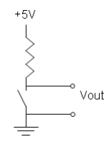

Figure 1. Circuit to Generate Pulse inputs

The resulting signal from the wind sensor is a pulse signal that has a frequency that is proportional to the wind speed. We will assume for this sensor that the wind distance traveled per revolution (T) is .1m. (We will initially use the function generator to simulate this waveform for testing while the sensor system is being implemented and calibrated.)

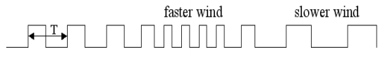

Figure 2. Sample Pulse Input

The LCD display will display the wind speed in real time as it changes. When the wind is not blowing, the LCD display will read 0 mph or 0 kph.

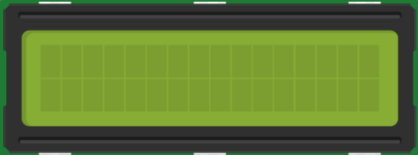

**Wind Speed: 10 mph**

Figure 3. Sample LCD Display

A possible graphical display will have a horizontal bar to indicate the wind speed. The higher the wind speed, the wider the bar will be.

Figure 4. VGA Output for Low and High Wind Speeds

Project I/O

The pulses will be input on one of the DE2 board GPIO pins. If time permits, there will also be a slider switch to select between a miles/hour and km/hour display output. One of the key inputs will be used as a global reset for the system.

If there is time to implement a graphical display, the VGA output will be used as well.

LCD Display

sensor pulses

Wind Meter System

VGA Display

km/miles

reset

Preliminary Test Plan

To ensure the meter is accurate, an attempt will be made to find a calibrated wind source for testing. Alternatively, a wind tunnel will be used to find the relationship between air speed and the sensor output, and then a logic analyzer or oscilloscope will be used to measure the pulse input and verify that the display output is correct for as wide a range of airspeeds that can be simulated in the lab.